UNIT 5:

**I. Leadership**

**What is Leadership?**

“The action of leading a group of people or an organisation.”

That’s how the Oxford Dictionary defines leadership. In simple words, leadership is about taking risks and challenging the status quo. Leaders motivate others to achieve something new and better. Interestingly, leaders do what they do to pursue innovation, not as an obligation. They measure success by looking at the team’s achievements and learning.

In contrast, management is about delegating responsibilities and getting people to follow the rules to reduce risk and deliver predictable outcomes. A manager is responsible for completing four critical functions: planning, organising, leading, and controlling.

Unlike leaders, managers do not challenge the status quo. Instead, they strive to maintain it. They evaluate success by seeing if the team has achieved what was expected.

**The 9 most common types of leadership**

Leadership styles can be unique to each individual. However, experts agree that most leaders fit into at least one of these nine different leadership styles. Lindor said when you analyze which leadership style you use, keep in mind that there are no right or wrong styles.

“It’s all about pairing leadership styles with the right organizational fit, market, timing and needs in a way that drives successful outcomes,” she said.

1. **Autocratic leadership:** This is one of the strictest types. Autocratic leaders tend to have complete control over the decision-making process. This leadership style can be effective when decision-making is urgent or workmanship is routine.
2. **Bureaucratic leadership:** Although not as strict as autocratic leaders, bureaucratic leaders also tend to strictly enforce regulations and statuses in the hierarchy. This leadership style can be effective in healthcare and safety environments.
3. **Charismatic leadership:** Charismatic leaders have an infectious presence that motivates their team to follow their lead. Their likability helps them and their teams achieve success in business. This leadership style can be effective in high-energy work environments that need a lot of positive morale.
4. **Democratic leadership:** Unlike autocratic or bureaucratic leaders, a democratic leader often welcomes subordinate participation in decision-making. This leadership style is often admired and can be effective in creative work environments that don’t require quick decisions.
5. **Laissez-faire leadership:** Laissez-faire leaders have a hands-off approach and let their employees assume responsibility in the decision-making process, although they must still [set employee expectations](https://www.businessnewsdaily.com/9451-clear-employee-expectations.html) and monitor performance. This leadership style can be effective when working with highly experienced and confident employees.
6. **Servant leadership:** Servant leaders share power and decision-making with their subordinates and often direct the organization based on the team’s interests. This leadership style can be effective for humanitarian organizations, nonprofits and teams that need to create diversity, inclusion and morale.
7. **Situational leadership:**Situational leaders implement a range of leadership types and modify their style based on the needs of their employees and the environment. Because of its versatility, this type of leadership is effective in most organizations.
8. **Transactional leadership:**A transactional leader uses a reward/consequence system to motivate employees toward success and discourage them from failure. This leadership style can be effective for teams that are motivated by rewards.
9. **Transformational leadership:** Like charismatic leaders, transformational leaders use their inspiring energy and personality to create an engaged workplace. This style is often more effective than charismatic leadership, as it also motivates teams to build confidence and accountability. It can be effective in organizations with intellectual team members who thrive in interactive environments.

## 20 Qualities of a Good Leader

### Collaborative

Leadership is a collective process that requires leaders and their team members to work together to achieve success. An effective leader focuses on aligning their goals to that of their team members. It keeps the employees and leaders on the same page about business goals and objectives.

### Accountable

An effective leader does not hold his team accountable for the failure of a project. Instead, they find out the root cause of the failure and discreetly work on solving the issue. This very quality of a good leader sets them apart from managers, who generally hold their subordinates responsible for every discrepancy.

### Courageous

An effective leader is courageous and can face difficult situations alone. They dare to do what they deem is right, a decision that leads them closer to their goal. Undeterred and unaffected, a good leader takes many decisions that seem unpopular at first but turn out to be successful.

### Good listener

A good listener understands, processes information communicated and acts upon it or provides feedback. An effective leader should be a good listener who works upon the information shared. Strong leaders also provide feedback and ask the right question at the right time.

### Effective communicator

This is one of the top [**leadership**](https://emeritus.org/in/learn/what-is-leadership/) qualities that every leader should possess. An effective leader’s words can light a fire in people that pushes them to achieve the unthinkable. A good leader should be articulate and put across their point succinctly. Effective communication ensures that business goals are met smoothly in the stipulated time.

### Flexibility

The adversities of the current business environment do not bother a good leader because they have a flexible personality trait that makes them accommodate change. This very quality of a good leader also helps them embrace different perspectives and empower team members by providing them with a place for growth. A leader works with a team of distinctive individuals from different walks of life. So, welcome new ideas with open arms.

### Empathetic

Leaders foster emotional intelligence, which helps them empathize with people around them. In addition, being an active listener helps them understand the thought process of their team and become a good leader.

### Focused

Being focused is one of the many distinctive qualities of a good leader. They are focused on achieving long term benefits for the business and their team. Good leaders push their team members towards achieving the best of their capabilities.

### Challenges status quo

An effective leader challenges the status quo rather than confiding in it. They guide their team members through difficult times and motivate them to do the same. This quality of good leaders differentiates them from average leaders and managers.

### Eager to learn

Effective leaders are aware that learning is a continuous process. Therefore, they undertake different [**leadership and management certification courses**](https://emeritus.org/in/programmes/business-management-and-leadership-courses/) to hone their skills. Besides that, they keep themselves updated with the ongoing business trends.

### Creative

Fostering creativity helps in solving business problems in innovative ways. An effective leader bustles with creative ideas to solve the hardest business problem tactfully. They also encourage creativity and innovation in their teams by conducting activities like brainstorming.

### Optimistic

Good leaders are optimistic about the future of their organization, it transcends to the team members, who leave no stone unturned to do their best in achieving business objectives.

### Passionate

Leaders direct their team members toward their goals. Effective leaders are passionate about their goals, and evoke the same emotion in their employees, who take their goals seriously and try tooth and nail to achieve them.

### Resilient

A good leader remains unaffected by failure, and they remain perceptive and resilient in difficult situations. A resilient leader focuses on the end result and not the journey. They communicate the same to their team, who follow the footsteps of their leader and set an example.

### Patient

Effective leaders know that mistakes and failures are inevitable. They remain patient during difficult times and offer guidance to team members who find it hard to tackle failures. A good leader works on resolving the issues.

### Transparent

Honest and open leaders foster a work environment that is efficient and enjoyable. An efficient leader must be transparent with their team members, making it one of the must-have qualities of a good leader.

Inspiration

An effective leader is a role model for many, from team members to colleagues. Everyone looks up to them for their dedication and hard work. They also inspire others to be the best version of themselves.

### Visionary

Leaders are strategists who formulate various strategies for the efficient functioning of the business. Therefore, leaders are visionaries who set the company in the right direction. An effective leader’s charisma ignites the fire in people to give their best.

### Self-aware

Another unique quality of a good manager is that they are self-aware of their skills and knowledge. Therefore, they work on honing what they know and what they may not be an expert in.

### Problem solver

Having problem-solving skills allows teams to effectively solve business problems and move past roadblocks. Good leaders are great problem solvers. Therefore, aspiring leaders undertake many certification courses to attain these skills.  
There is no litmus test to evaluate the effectiveness of leadership. However, the above-mentioned qualities of good leaders guide aspiring leaders to develop these skills to excel in their job. In the succeeding sections, we’ll discuss the characteristics of a good leader, and enlist the skills required by a leader.

## Characteristics of a Good Leader

Leadership is about solving problems, fostering creativity, aligning business goals to personal goals, and more. Therefore, a leader must have peculiar characteristics that distinguish them from other business roles. If you aspire to become a good leader, here are the characteristics that will make anyone an effective one.

### Influential

Leaders must exercise authority from the first day of the project. Then, gradually, increase the influence over the team to steer them in the direction you think the company should head to achieve their long-term goals.

### Transparency

Another characteristic of a good leader is transparency. The more open leaders are to the organization’s goals and challenges, the easier it is for the team to understand their role in the business. However, never be overtly transparent with employees; draw boundaries on the information you would and wouldn’t share from the first day.

### Encourage innovation

Innovation ensures that the company has a competitive advantage. It is the guiding force behind the success of a brand. Therefore, leaders must encourage teams to foster innovation and creativity within the organization.  
Innovation can often lead to failure, so develop an ecosystem that embraces failures. It encourages the employee to experiment as they see creativity is valued in the company.

### Value ethics

To ensure maximum employee engagement and motivation, a leader must adopt high ethical standards in the business. It fosters a safe environment where everyone feels valued. Employees want their leaders to treat them fairly.

### Decisiveness

The evolving complex business environment forces leaders to make strategic decisions quickly, making decisiveness one of the important characteristics of a good leader. However, an effective leader sticks to their decision unless there is a compelling reason to shift focus.

There are many different leadership skills required in the workplace, but the most in-demand ones include:

1. Active listening
2. Empathy
3. The ability to share clear messages and make complex ideas easy to understand for everyone
4. Strategic thinking skills
5. Creativity
6. The ability to inspire and convince others
7. Flexibility
8. The ability to turn information into action
9. Project planning
10. Active listening
11. The ability to assess employees’ strengths and weaknesses
12. Business storytelling
13. Time management
14. The ability to build trust
15. Strong communication skills
16. Positivity
17. Reliability
18. Management skills
19. The ability to align the employees with the [company values](https://haiilo.com/blog/the-importance-of-company-values/) and goals
20. A strong leadership vision
21. Recruiting skills
22. Persuasion skills
23. The ability to help employees find meaning at work
24. Strong charisma

|  |  |
| --- | --- |
| LEADER | MANAGER |
| Leaders have missions to accomplish | Managers are goal-oriented |
| Leaders challenge the status quo | Managers maintain or try to achieve the status quo |
| Leaders are unique | Managers mimic their competitors |
| Leaders take risk | Managers avoid taking risk |
| Leaders are willing to learn and grow personally | Managers perfect existing, proven skills |
| Leaders build relationships | Managers focus on goals and objectives |
| Leaders coach people to become a better version of themselves | Managers direct people to achieve the company goal |
| Results of leadership are intangible | Results of management is measurable |
| Leadership is qualitative | Management is quantitative |
| Leaders have fans | Managers have employees |

**II. Organizational Climate**

**What is organizational climate?**

Organizational climate refers to an employee’s long-lasting perception of the working environment and culture of the business they work for. You can think of climate as similar to personality: every person has a unique personality, and every organization has a unique climate. This is reflected as a set of characteristics and features perceived by employees. These influence employees’ behavior at work across various dimensions such as relationships, autonomy, and organizational structure.

A positive organizational climate increases [organizational commitment](https://www.aihr.com/blog/organizational-commitment/) – the bond employees have with their organization.

Climate is not created overnight; rather, it is built up and shaped over a long period through a collation of experiences and interactions. For example:

* whether an employee feels trusted to perform their role without micromanagement,
* how managers and peers treat them,
* whether they feel like they’re growing and developing within the organization,
* how effectively conflict is managed,
* how incentivized they are to perform,
* and much more.

Businesses can use organizational climate to gauge how employees feel about their policies, practices, and culture and ensure these align with their overall vision, long-term goals, and strategy. This is key to creating a workplace environment that your employees love and thrive in. The happier they are, the more productive they will be, and the stronger their results.

## Types of organizational climate

Organizations tend to have a mix of several types of organizational climate rather than just one, but there will often be one dominant type.

Here are the common types of organizational climate:

|  |  |
| --- | --- |
| **People-oriented climate** | An organizational culture that has a core set of values that focus predominantly on caring for its employees and their results. |
| **Rule-oriented climate** | An organizational culture providing a set of rules and structure and places high importance on following these rules and attention to detail from everyone. |
| **Innovation-oriented climate** | An organizational culture that consistently develops and introduces new ways of working and processes (and encourages employees to do the same) to achieve innovative results. |
| **Goal-oriented climate** | An organizational culture that places preference on values and refining details of processes to achieve the desired result. |

**How to improve organizational climate**

Now that we’ve answered the question ‘What is an organizational climate?’, let’s take a look at a few strategies you can use to create a positive and nurturing environment in your business.

Evaluate your current organizational climate

The first step, before you can implement any improvement initiatives, is to evaluate the current climate in your organization.

A good tool for measuring the climate of an organization is sharing an [employee satisfaction survey](https://factorialhr.com/blog/employee-satisfaction-survey/) or, more specifically, an organizational climate survey. These handy forms give employees the opportunity to provide feedback on matters relating to management, training, compensation, working environment, and recognition, amongst other areas. You can then use the results you collect to gain an insight into your current climate so that you know which areas you need to work on. We’ll discuss this in a little more detail below.

Improve your working environment

Another important area that has a direct impact on your organizational climate is the environment you provide your employees with. Make sure you are offering all staff, whether remote or in-house, a [healthy working environment](https://factorialhr.com/blog/how-to-create-a-healthy-work-environment/). This doesn’t necessarily mean buying them top-of-the-range technology and devices. Rather, it means creating a comfortable workspace that inspires creativity and is conducive to work. For example, think about the furniture you have and the color schemes you use in your office.

It also means nurturing the [employee experience at your company](https://factorialhr.com/blog/nurturing-employee-experience/) by developing a [growth mindset](https://factorialhr.com/blog/growth-mindset-meaning/) and promoting a sense of [psychological safety at work](https://factorialhr.com/blog/psychological-safety-work/). For instance, how user-friendly are your internal processes? Are you using the right [HR software](https://factorialhr.com/) to promote a positive experience at every stage of the employee lifecycle?

Create an employee recognition program

An [employee recognition program](https://factorialhr.com/blog/employee-recognition-programs/) is another creative strategy for [showing appreciation to your employees](https://factorialhr.com/blog/show-appreciation-employees/) and boosting your organizational climate. Recognition can take the form of a public shoutout, a small gift, a day off, or a monetary bonus, for example. This can help you communicate how much you value [employee empowerment](https://factorialhr.com/blog/what-is-employee-empowerment/) and provide your workforce with the [emotional salary they need to be happy employees](https://factorialhr.com/blog/emotional-salary-employee-happiness/). This is also a great way to create a healthy sense of competition in your departments.

Develop a strong leadership style

There’s a strong link between your emotional intelligence leadership style and organizational climate. It’s therefore crucial that you nurture a leadership style that supports your goals and promotes transparency and communication. After all, your leaders have perhaps the biggest impact on how inspired and motivated your employees feel. Make sure you offer regular training to your managers so that they have the skills and tools they need to create a positive environment for their teams.

Encourage autonomy

Finally, encourage autonomy and praise employees who work proactively and use their initiative. Make sure everyone understands how their individual performance contributes to the company’s mission and goals. When employees are encouraged to think for themselves and have clear guidelines relating to their roles and responsibilities, they are far more likely to feel motivated to perform well. They will also get a sense of satisfaction from knowing that what they do has a direct positive impact on the company: that they matter.

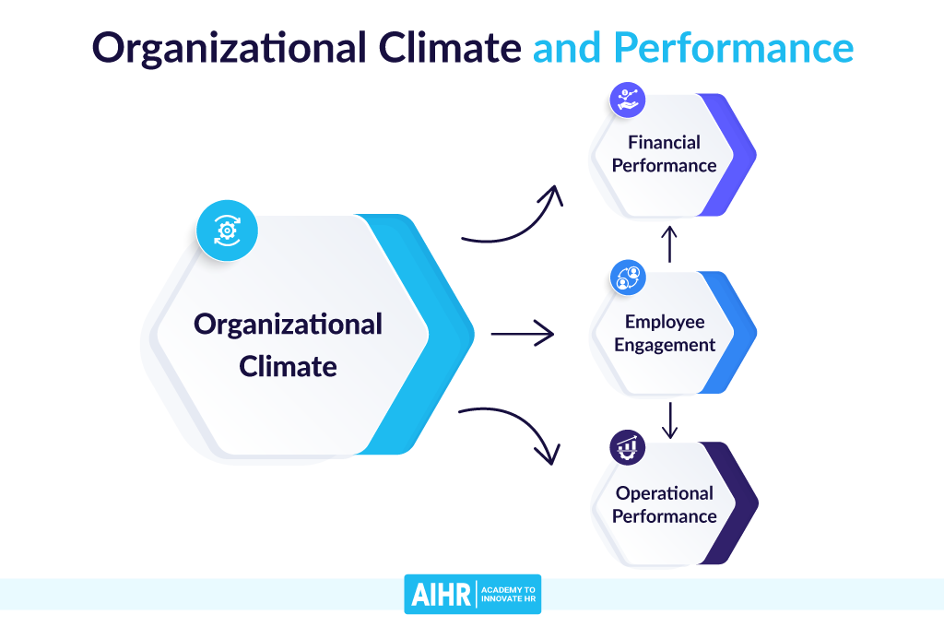

**III.** **Organizational Culture**

Organizational culture is generally understood as all of a company’s beliefs, values and attitudes, and how these influence the behaviour of its employees.

Culture affects how people experience an organization—that is, what it’s like for a customer to buy from a company or a supplier to work with it. It shows up in company policies such as dress code and office hours. It also informs things such as workspace design and employee perks. Culture is usually set by a company’s leaders.

Companies don’t tend to define their cultures explicitly; they tend to emerge from what people believe, how they think, what they say and what they do. Culture shapes what behaviour is acceptable or unacceptable. Culture may help define values and core principles that guide organizational behaviour.

## TYPES OF ORGANIZATIONAL CULTURES

## Type 1: Clan culture

Have you heard people refer to their coworkers as their family? That’s an indication that they’re working in a clan culture (also called a “[collaborate culture](https://www.ocai-online.com/about-the-Organizational-Culture-Assessment-Instrument-OCAI)”), where there’s a lot of emphasis placed on teamwork and togetherness.

Clan cultures offer a very friendly working environment where things like relationships, morale, participation, and consensus take center stage. In terms of leadership, managers are looked to as mentors, rather than figureheads who dish out instructions and reprimands.

### **Pros of this culture type:**

* A happy team who genuinely enjoys working together.
* Improved communication between employees.

### **Cons of this culture type:**

* Too much collaboration or unnecessary chatter, which can send productivity into a nosedive.
* Inability to make tough decisions because other people’s feelings are of such high priority.

### **Example of this culture type:**

Online shoe and clothing retailer, Zappos, is often praised for having a positive culture – so much so that the company’s CEO literally [wrote a book](https://www.amazon.com/Delivering-Happiness-Profits-Passion-Purpose/dp/0446576220) on their culture of happiness. With “build a positive team and family spirit” as one of their ten core values, they best fit the clan culture model.

## Type 2: Adhocracy culture

Rooted in the word ad hoc, this type of culture lives by that “move fast and break things” philosophy that’s been popular among a lot of startups. You might also hear it referred to as the “create culture.”

Quinn and Cameron explain that this type of culture fosters a very entrepreneurial type of work environment, where employees are encouraged to take risks and aggressively pursue off-the-wall ideas. As a result, a lot of innovation, learning, and growth takes place – for employees and the organization as a whole.

### **Pros of this culture type:**

* An enormous amount of innovation and growth.
* Increased [psychological safety](https://www.atlassian.com/blog/teamwork/team-productivity-tips-and-research), which means employees feel secure trying new things.

### **Cons of this culture type:**

* A seeming lack of stability because so much is invested in new initiatives.
* Sense of intimidation for newbies who don’t have the expertise to work quickly and aggressively.

### **Example of this culture type:**

Google didn’t become one of the most well-known tech companies in the world by resting on its laurels. The company is all about innovating to improve search and launch new offerings, which means their culture is best described as an adhocracy culture. Another good example of adhocracy culture is Facebook, although their “move fast and break things” mentality [has had to shift recently](https://hbr.org/2019/01/the-era-of-move-fast-and-break-things-is-over) due to increased consumer vigilance.

## Type 3: Market culture

A market culture is also called a “compete culture,” because the emphasis is placed on results. To put it simply, people want to win and accomplish what they set out to do.

Employees are highly goal-focused and leaders are tough and demanding in order to achieve the success metrics the company has defined. It can be a high-pressure environment, but simultaneously rewarding when that hard work pays off with real, measurable results.

### **Pros of this culture type:**

* Employees are driven and highly motivated to achieve their goals.
* Improved performance for the company, because everybody is committed to success.

### **Cons of this culture type:**

* Encouraging constant competition can lead to a toxic work environment.
* Employees can experience stress and even burnout as a result of the constant pressure.

### **Example of this culture type:**

Amazon often [made headlines](https://www.entrepreneur.com/article/312942) for a company culture that can only be described as, well… relentless. Employees have spoken openly about the fact that they’re expected to deliver results and climb the ladder, no matter the personal cost. While Amazon would likely refute these claims, the company’s obvious emphasis on success means they still fit the market culture mold. One of Amazon’s leadership principles is to “deliver results.” “Leaders focus on the key inputs for their business and deliver them with the right quality and in a timely fashion,” the company says of [their values](https://www.amazon.jobs/en/principles). “Despite setbacks, they rise to the occasion and never settle.”

## Type 4: Hierarchy culture

A hierarchy culture (also known as a “control culture”) applies to work environments that are more structured and process-oriented. Most activities and decisions are dictated by existing procedures, rather than a lot of innovation and freethinking.

Leaders are in place to ensure that their teams run like well-oiled machines, and they place the bulk of their focus on stability, results, and reliable delivery.

### **Pros of this culture type:**

* There’s a lot of clarity in communication and expectations because nearly everything is prescribed.
* Employees experience a greater sense of security and predictability.

### **Cons of this culture type:**

* Prioritizing procedures over people can make the environment feel inflexible and even unsupportive.
* Too much rigidity can stifle innovation and growth because people are afraid to think outside of the box.

### **Example of this culture type:**

A good chunk of government organizations will subscribe to a hierarchy culture. Because they face a lot of regulations and are often under their fair share of scrutiny, they prioritize policies and procedures above nearly anything else. They have to do things by the book, so to speak. Additionally, paths to advancement are clearly outlined for employees. There’s no guesswork.

**IV.** **Organizational Development**

# What Is Organization Development?

[Organization development](https://tdcapability.org/#/organizational/organization-development-and-culture) (OD) is an effort that focuses on improving an organization’s capability through the alignment of strategy, structure, people, rewards, metrics, and management processes. It is a science-backed, interdisciplinary field rooted in psychology, culture, innovation, social sciences, adult education, human resource management, [change management](https://www.td.org/insights/change-management-is-a-vital-capability-for-td-professionals), organization behavior, and research analysis and design, among others.

[Organization development](https://www.td.org/insights/organization-development-and-culture-are-vital-capabilities-in-talent-development) involves an ongoing, systematic, long-range process of driving organizational effectiveness, solving problems, and improving organizational performance. It is also one of the capabilities identified in the [Talent Development Capability Model](https://www.td.org/capability-model).

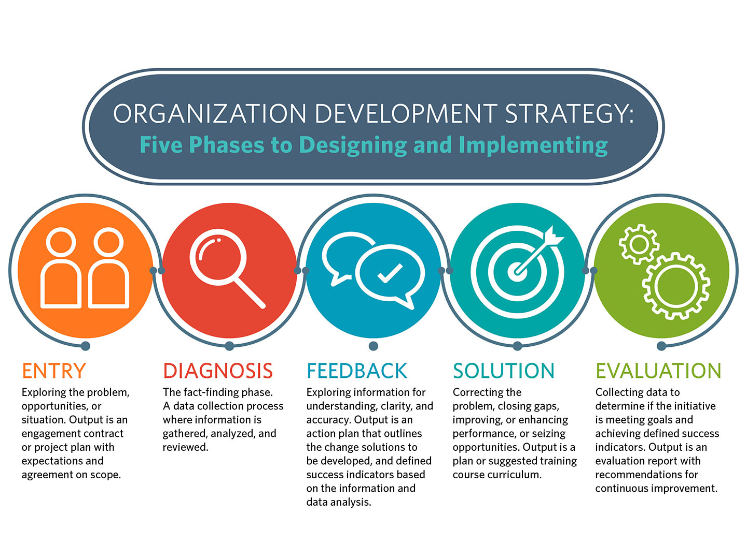

**OD Strategy: Five Phases**

TD professionals should integrate OD skills with the growing number of L&D, [performance improvement](https://www.td.org/insights/performance-improvement-is-a-vital-capability-for-td-professionals), and talent management solutions focused upon increasing organizational effectiveness. The process used by OD practitioners to design and implement organizational development strategies is structured in five phases:

1. Entry represents the initial contact between consultant and client in which they present, explore, and identify the problem, opportunities, or situation. The output of this phase is an engagement contract or project plan that establishes mutual expectations and preliminary agreements about project scope (such as time, money, and resources).
2. Diagnosis (assessment) represents the fact-finding phase. It is a collaborative data gathering process between organizational stakeholders and the consultant in which relevant information about the presenting problem is gathered, analyzed, and reviewed.
3. Feedback represents the return of analyzed information to the client or client system; exploration of the information for understanding, clarity, and accuracy; review of preliminary agreements about scope and resource requirements; and the beginning of ownership of data by the client. The output of this phase is typically an action plan that outlines the change solutions to be developed, along with defined success indicators based on the information and data analysis.
4. Solution represents the design, development, and implementation of the solution or set of solutions meant to correct the problems, close gaps, improve or enhance organizational performance and effectiveness, or seize opportunities. Outputs may include a communication plan, a role-and-responsibility matrix, a training plan, a training curriculum, an implementation plan, a risk management plan, an evaluation plan, or a change management plan.<.li>
5. Evaluation represents the continuous process of collecting formative and summative evaluation data to determine whether the initiative is meeting the intended goals and achieving defined success indicators. Outputs generally include an evaluation report with recommendations for continuous improvement.

**What Are Some Organization Development Initiatives?**

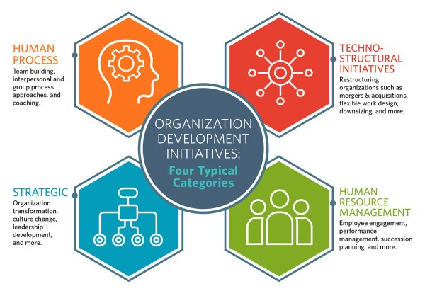

Organization development initiatives are typically categorized as:

* Human process initiatives that include team building, interpersonal and group process approaches, and coaching
* Techno-structural initiatives that include restructuring organizations (for example, mergers and acquisitions, flexible work design, downsizing, business process engineering, total quality management, quality of work life, Six Sigma, and Agile)
* Human resource management initiatives that include [employee engagement](https://www.td.org/insights/the-real-world-of-employee-engagement), employee experience, performance management, [employee development](https://www.td.org/insights/3-employee-development-best-practices), succession planning, coaching and mentoring, career development, and [diversity awareness](https://www.td.org/insights/cultural-awareness-and-inclusion-is-a-vital-capability-for-td-professionals)
* Strategic initiatives that include organization transformation, culture change, leadership development, and attraction and retention initiatives.

The Organizational Development Process Cycle

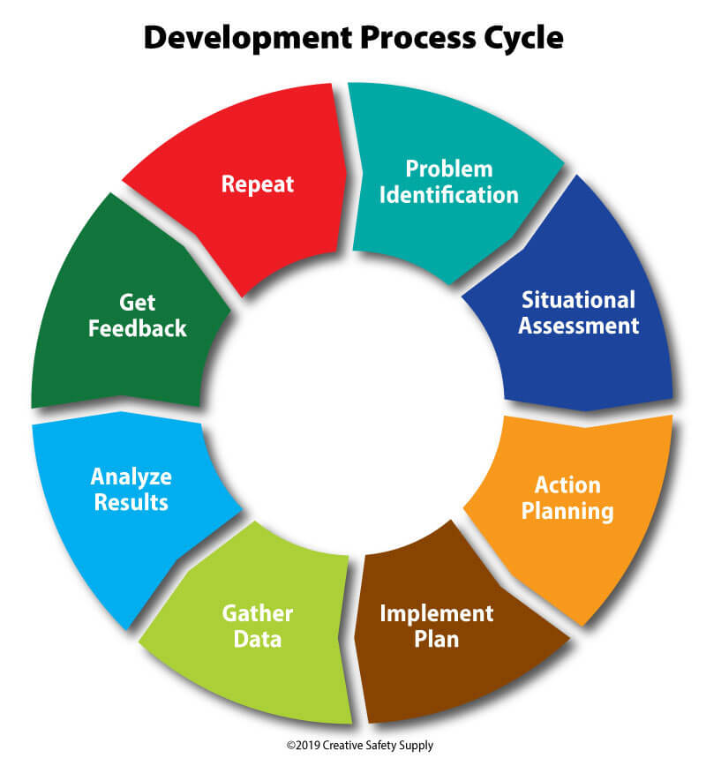

Organizational development begins when a problem is identified. This system can be used to make improvements on just about any situation or problem that a business can face. It is a broad set of steps that are easily understood and provide companies with the ability to quickly make changes to solve issues. Once the changes are made, they can be evaluated to see if the problem was resolved, and if not, it will continue through the development process.

This process runs through the following steps:

Problem Identification – A problem can be identified in a wide-range of ways including reports from employees, data gathering, etc.

Situational Assessment – Making a formal assessment of the situation is the next step. This can be done by reviewing documentation, holding focus groups, interviewing, or surveying. Gathering all the facts related to the problem at hand is important for developing an effective solution.

Action Planning – Planning how the problem will be solved is the next step. This should be done by incorporating input from all impacted parties so that a solution that addresses the specific problem at hand can be found. In many cases, this will be the longest step in the process.

Implement Plan – Take the plan made in the previous step and put it into action. Depending on the complexities of the change, this may include training and other steps needed to ensure the action plan is put in place correctly.

Gather Data – As soon as the change is put in place, it is time to start gathering data. This should be done with a focus on identifying whether the changes made are having a positive impact on the problem at hand.

Analyze Results – Look at the gathered data to see if the plan has improved the problem, eliminated the problem, did nothing to the problem, or made the problem worse. In addition, watching to see if the changes had any secondary, negative, impacts on other issues is also done here.

Get Feedback – Gathering feedback from all impacted parties must happen next. If the problem has been eliminated, but it increases the risk of injury for employees, for example, then it wasn't a good solution.

Repeat – If necessary, the process will be repeated. If the changes made had some positive impact, then the process will begin with the current system in place. If they didn't, it may be beneficial to go back to the original way things were done to reevaluate.

**V. Teams in Organizations**

A team is defined as a group of people who perform interdependent tasks to work toward accomplishing a common mission or specific objective.

Some teams have a limited life: for example, a design team developing a new product, or a [continuous process improvement](https://asq.org/quality-resources/continuous-improvement) team organized to solve a particular problem. Others are ongoing, such as a department team that meets regularly to review goals, activities, and performance.

An organization with many teams requires careful alignment. As teams and individuals link with other teams, the principles of developing understanding and trust will apply, but the structure will get more complex (Figure 1). Understanding the many interrelationships that exist between organizational units and processes, and the impact of these relationships on quality, productivity, and cost, makes the value of teams apparent.

Common organizational teams include **change management teams and quality assurance teams**. The team members work separately and together to achieve success in their tasks, which serve in promoting the overall welfare and success of the organization as a whole

## THE THREE TYPES OF TEAMS

Many of today’s team concepts gained popularity in the United States during the 1970s through the use of quality circles or [employee involvement](https://asq.org/quality-resources/employee-empowerment) initiatives. However, these initiatives were often seen as separate from normal work activities, not as integrated with them.

Team designs have since evolved into a broader concept that includes many types of teams formed for different purposes.

Three primary types of teams are typically used within the business environment:

### Process Improvement Teams

Process improvement teams are project teams that focus on improving or developing specific business processes. These teams come together to achieve a specific goal, are guided by a well-defined project plan, and have a negotiated beginning and end.

### Work Groups or Natural Teams

Work groups, sometimes called "natural teams," have responsibility for a particular process (e.g., a department, a product line, or a stage of a business process) and work together in a participative environment. The degree of authority and autonomy of the team can range from relatively limited to full self-management. The participative approach is based on the belief that employees will be more productive if they have a higher level of responsibility for their work.

### Self-Managed Teams

Self-managed teams directly manage the day-to-day operation of their particular process or department. They are authorized to make decisions on a wide range of issues, such as [safety](https://asq.org/quality-resources/safety), quality, maintenance, scheduling, and personnel. Their responsibilities also include processes traditionally held by managers, such as goal-setting, allocation of assignments, and conflict resolution.

THE VALUE & BENEFITS OF TEAMS

Team processes offer the following benefits to the organization:

* Synergistic process design or [problem solving](https://asq.org/quality-resources/problem-solving)
* Objective analysis of problems or opportunities
* Promotion of cross-functional understanding
* Improved quality and productivity
* Greater [innovation](https://asq.org/quality-resources/innovation)
* Reduced operating costs
* Increased commitment to organizational mission
* More flexible response to change
* Increased ownership and stewardship
* Reduced turnover and absenteeism

Individuals can gain the following benefits from teams:

* Enhanced problem-solving skills
* Increased knowledge of interpersonal dynamics
* Broader knowledge of business processes
* New skills for future [leadership roles](https://asq.org/quality-resources/leadership)
* Increased quality of work life
* Feelings of satisfaction and commitment
* A sense of being part of something greater than what one could accomplish alone

REASONS WHY TEAMS FAIL

Difficulty with teams is often blamed on a cultural emphasis in the United States on individual accomplishments versus shared responsibility and success. But problems are also caused by inadequate organizational support structures, reward systems, for example, often reinforce individual performance.

Numerous reasons have been noted for why teams often fail to reach their full potential. Among them are:

* Failure to integrate cooperative work methods into the organizational culture
* Lack of organizational systems necessary to support the team process
* Minimal upfront planning of how the organization plans to utilize teams
* Failure to prepare managers for their changing roles
* Failure to prepare team members for their new roles
* Inappropriate reward and compensation systems
* Inadequate training
* Impatience of top management with the time needed for maturation
* Incomplete understanding of group dynamics

**UNIT 6: Stress Management: Demands of Life and Work**

**Stress management**

Stress management offers a range of strategies to help you better deal with stress and difficulty (adversity) in your life. Managing stress can help you lead a more balanced, healthier life.

Stress is an automatic physical, mental and emotional response to a challenging event. It's a normal part of everyone's life. When used positively, stress can lead to growth, action and change. But negative, long-term stress can lessen your quality of life.

Stress management approaches include:

* Learning skills such as problem-solving, prioritizing tasks and time management.
* Enhancing your ability to cope with adversity. For example, you may learn how to improve your emotional awareness and reactions, increase your sense of control, find greater meaning and purpose in life, and cultivate gratitude and optimism.
* Practicing relaxation techniques such as deep breathing, yoga, meditation, tai chi, exercise and prayer.
* Improving your personal relationships.

### **Healthy Ways to Cope with Stress**

Feeling emotional and nervous or having trouble sleeping and eating can all be normal reactions to stress. Here are some healthy ways you can deal with stress:

* **Take breaks from watching, reading, or listening to news stories**, including those on social media. It’s good to be informed but hearing about the traumatic event constantly can be upsetting. Consider limiting news to just a couple of times a day and disconnecting from phone, tv, and computer screens for a while.
* **Take care of yourself.** Eat healthy, exercise, get plenty of sleep, and give yourself a break if you feel stressed out.
* **Take care of your body**.
  + Take deep breaths, stretch, or [meditate](https://www.nccih.nih.gov/health/meditation-in-depth).
  + [Try to eat healthy, well-balanced meals](https://www.cdc.gov/nccdphp/dnpao/features/national-nutrition-month/index.html).
  + [Exercise regularly](https://www.cdc.gov/physicalactivity/basics/index.htm).
  + [Get plenty of sleep](https://www.cdc.gov/sleep/about_sleep/sleep_hygiene.html).
  + Avoid [excessive alcohol, tobacco, and substance use](https://www.cdc.gov/coronavirus/2019-ncov/daily-life-coping/stress-coping/alcohol-use.html).
  + Continue with routine preventive measures (such as vaccinations, cancer screenings, etc.) as recommended by your healthcare provider.
  + [Get vaccinated](https://www.cdc.gov/coronavirus/2019-ncov/vaccines/your-vaccination.html) against COVID-19 as soon as possible; [get a booster shot](https://www.cdc.gov/coronavirus/2019-ncov/vaccines/booster-shot.html) if you are age 18 or older.
* **Make time to unwind**. Try to do some other activities you enjoy.
* **Talk to others.** [Talk with people](https://howrightnow.org/talk) you trust about your concerns and how you are feeling. Share your problems and how you are feeling and coping with a parent, friend, counselor, doctor, or pastor.
* **Connect with your community- or faith-based organizations**.
* **Avoid drugs and alcohol.** These may seem to help, but they can create additional problems and increase the stress you are already feeling.
* **Recognize when you need more help.** If problems continue or you are thinking about suicide, talk to a psychologist, social worker, or professional counselor.

## 4 benefits of learning to manage stress

Learning to manage stress effectively is crucial for your [long-term health and well-being](https://www.betterup.com/blog/physical-well-being-and-health-what-it-is-and-how-to-achieve-it?hsLang=en). Here are four of the main benefits of using stress management techniques:

1. **A stronger immune system**. Stress weakens the immune system and makes you more vulnerable to illness. Relaxation and stress reduction help strengthen your natural defenses.
2. **It is easier to maintain a healthy weight.** Stress can cause us to eat or drastically reduce our appetite. And it doesn’t usually have us reaching for the salad. Instead, we go for junk food loaded with sugar, saturated fat, and salt. This reaction to stress can cause weight gain. But reducing your stress levels can help control your appetite and cravings.
3. **Better sleep.** Stress makes it difficult to sleep due to the excess adrenaline it releases into the bloodstream, causing muscle tension. Stress management can increase endorphins, which help with muscle relaxation and [promote sleep](https://www.betterup.com/en-us/resources/blog/sleep-hygiene?hsLang=en).
4. **Improved mood and relationships.** Stress can cause you to be moody and irritable. These attitude changes affect the way you react to those nearest to you. As a result, [it can put a strain on your relationships](https://www.betterup.com/blog/your-well-being-and-relationships-coach-tips?hsLang=en). Reducing your stress levels can help restore balance.